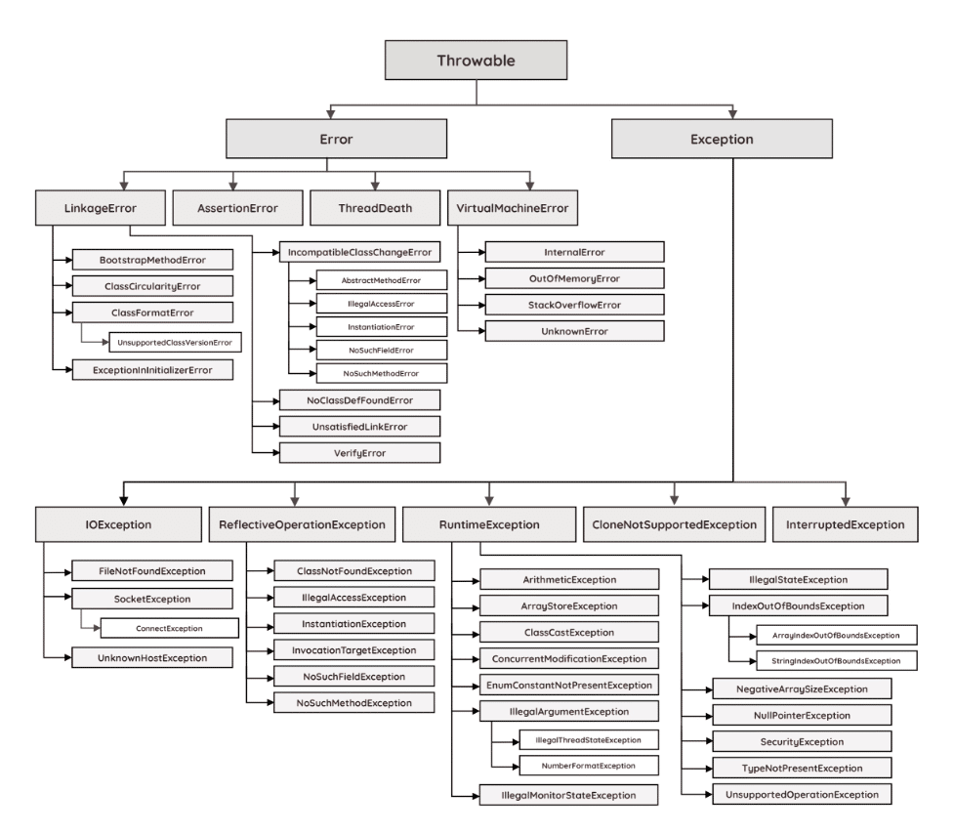

Checked vs Unchecked Exception in Java

🔹 1️ Checked Exception
👉 Checked at compile time
✔ Compiler forces you to handle it
✔ Must use try-catch OR throws
If you don’t handle → program will NOT compile

Examples:
- IOException
- SQLException
- FileNotFoundException
- ClassNotFoundException

Example:
import java.io.*;
public class Test {
public static void main(String[] args) throws IOException {
FileReader file = new FileReader("abc.txt");
System.out.println("File opened");
}
}
If you remove throws IOException → compilation error.

🔹2 Unchecked Exception
👉 Checked at runtime
✔ Compiler does NOT force handling
✔ Handling is optional
These are subclasses of RuntimeException

Examples:
- ArithmeticException
- NullPointerException
- ArrayIndexOutOfBoundsException
- IllegalArgumentException

Example:
public class Test {
public static void main(String[] args) {
int a = 10;
int b = 0;
int result = a / b; // ArithmeticException at runtime
System.out.println(result);
}
}
This compiles successfully but crashes at runtime.

🔥 Difference Table
Feature | Checked Exception | Unchecked Exception
Checked at | Compile time | Runtime
Must handle? | Yes | No
Extends | Exception | RuntimeException
Compiler error if not handled? | Yes | No

Exception Hierarchy
Object
↓
Throwable
↓
Exception
↓
Checked Exceptions
↓
RuntimeException
↓
Unchecked Exceptions

Checked Exception → Exception checked at compile time and must be handled.
Unchecked Exception → Exception checked at runtime and handling is optional.

